**ENERGY EFFICIENT TOWER FANS:**

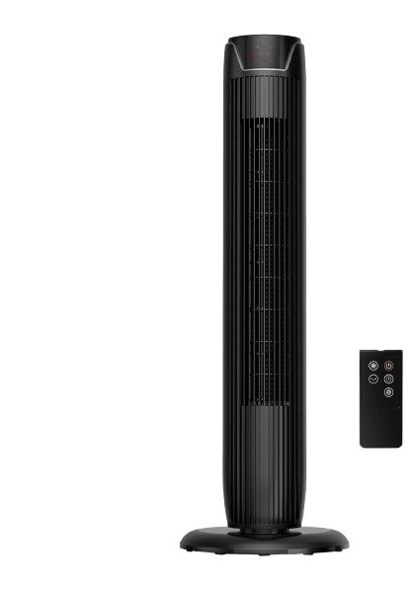

**Price: 15,000.00**

The Energy Efficient Tower Fan is a cutting-edge cooling solution designed to provide powerful airflow while minimizing energy consumption. With its advanced motor technology and aerodynamic design, this fan delivers a refreshing breeze while using significantly less energy than traditional fans. Its sleek tower profile, adjustable speed settings, and whisper-quiet operation make it perfect for eco-conscious homeowners and businesses seeking a cost-effective and environmentally friendly cooling solution.

**Key features of energy efficient tower fans include:**

* **Low Power Consumption**: Designed to use less energy.
* **Multiple Speed Settings**: Customizable airflow for optimal efficiency.
* **Quiet Operation**: Minimal noise for a comfortable environment.
* **Slim, Space-Saving Design**: Fits easily in small spaces.
* **Eco-Friendly**: Reduces energy costs while providing effective cooling.